Contents

Functionality Objective 2

Business Justification 2

Key Results 3

Overall Partners and Dependencies 3

1 Scenario1: Bring the S 500 customer escalation and critical bug data to shiproom 4

Requirements 4

1.1 Historical chart with #bugs per channel month over month – Start with May 2019 6

1.2 triaged decision Accepted Fixed vs Reject total 6

1.3 chart for internally opened or customer reported w/ ticket id 7

1.4 Bar chart by tenant name top 10 – stack bar chart 7

1.5 total bugs per team – top 10 8

1.6 GEM table with the data (All except state = closed) 8

1.7 Phase 2 8

1.8 Chart with MTTR – LOOKS like it is Isabelle SLA which Stephen is BUILDING) 8

2 Scenario2: Bring latest build released to S customer and # of customers on EOS builds 9

2.1 Build tab 10

2.2 How to access data for build version information? We’ve 2 options - 11

2.2.1 Visual w/o tenant id filter 11

2.2.2 Visual with tenant id filter – not sure if we can do this due to tenant id exposure. 12

2.2.3 Per tenant deep dive data we should link to http://aka.ms/oxotenantcurr 13

2.3 Why do we need this report? 13

|  |  |  |
| --- | --- | --- |
| A close up of a logo  Description generated with very high confidence |  | |
| Strategic Customer Shiproom View | |
|  | PM: Archana Gadkari |

# Functionality Objective

We have an obligation to provide great customer services to the S500, S1500 and S20 customers, where we’ve data that tell us about escalation and fix rates (bugs), the builds they are on & are those build have any issues ( crash ratio, reliability and perf issues), what % of S customers are on MT, MC, SACT and SAC and their ratio, & are there any outliers which we do not know about.

# Business Justification

Goal is to have a view where all the S customer data is available one single place to be reviewed in Shiproom. Today S500 customer data might exist but all over the place, DIG has bunch of dashboard, C2R does too and then Amplify team some data, but we need to have view with a build pivot

The S500 view should be able answer following questions –

**Bugs –**

Total Number of escalations reported by S customers? Categories per channel (see build progression UI in team view) (p1)

Graphical representation of (graph representation which shows the count day by day) (p1) –

Initial triage decision – Accept or Reject

Out of the escalation that are Accepted fixed vs Accepted rejected other resolution (won’t fix, Not repro, duplicate or external)

Data which shows the rate and communication back to the S500? (p2)

There should a tag or release notes/ know issues indicator in VSO to identify customer contact/communication.

**Builds (C2R) Progression– Need to work with DIG or IDEAS**

What builds S customers uses? (last 5 build released to MT, Monthly prod, SAC-T and SAC)

How are the builds doing? (drilldown on build numbers to show by per tenant view)

What the ratio & channels – MT, MC, SACT and SAC? (have pie chart and upon clicking on the number it expands to the list of tenants)

Any outliers – do we know which S customers are in Weird state?

When we release a build which tenants are impacted/ affected?

Who is not using the target builds? Or anybody is < X % of tenants/devices on targeted?

**Audience signals by builds**

**Customer Feedback loop** (should this be on the shiproom dashboard?)

How are we doing in closing the loop with Customers feedback/escalations/Customer impacting issues we’ve identified (such as reliability, perf...etc)?

# Key Results

*Enumerate 3 to 5 measurable outcomes or KPI’s that will be positively affected.*

KR Project – reporting in one place to answer all the questions & provide insight on how S customers are doing.

KR Business – Customer impact

# Overall Partners and Dependencies

*High-level call-out of the partners and dependencies for the feature. Indicate if there is a delivery timeframe constraint with the partnership.*

DIG - <https://metrical.azurewebsites.net/TenantInsights>  
C2R – for Deployment per tenant info

Amplify – S500 escalation info

IDEAs – tenant IDs information (??)

Things we need -

* API - list of tenant ids (and based on the list of tenant ids we can find which builds are being used by the S customers).
* API - C2R/deployment so that tie the builds with the tenant id (ELF- Naomi)
* VSO for crash ratio, reliability, and perf info

# Scenario1: Bring the S 500 customer escalation and critical bug data to shiproom

* **Scenario narratives:**

Tara, CSE VP is in shiproom. Before she didn’t have visibility into S customer impacting bugs and how it drives customer satisfaction. Now, having a shiproom view allows her to see the S customer impacting bugs and enables her to drive necessary actions with appropriate teams.

* **Description of the proposed solution**

Dashboard which shows the S customer bug

* **Prioritized Functional Requirements (High-Level)**
  + - 1. Total Number of bugs reported by S customers or we found through telemetry?
         1. Categories per channel (similar to build progression UI in team view)
      2. Graphical representation of (graph representation which shows the count day by day) –
         1. Initial triage decision – Accept or Reject
         2. Out of the escalation that are Accepted fixed vs Accepted rejected other resolution (won’t fix, Not repro, duplicate or external)
      3. Data which shows the rate and communication back to the S500?
         1. there should a tag or release notes/ know issues indicator in VSO to identify customer contact/communication.

|  |  |  |  |
| --- | --- | --- | --- |
| **#** | **Requirement** |  | **Priority** |
|  | New page on MRO UI – S Customer under shiproom in left nav |  | P1 |
|  | Bug section |  | P1 |
|  | List of Bugs (Sev0, Sev1 and Sev2) – all channels include customer escalation, perf, reliability…etc (for now they all will be in one list) (#1 above) |  | P1 |
|  | Categories list of bugs (#1 a above) |  | P2 |
|  | Graphical representation of bugs decision (#2 above) |  | P1 |
|  | Customer communication (#3 above) |  | P2 |

* **Partners and Dependencies**

*High-level call-out of the partners and dependencies for the feature.*

|  |  |
| --- | --- |
| **Who** | **What** |
| DIG | Auto creation and decoration of Watson and reliability bugs |
| FUEL | Manual creation and decoration of Perf bugs |
| Office ADO | Bug database |

Open issue -

* When do the bug become blocking?

# Requirements

**Overall VSO Query -** <https://office.visualstudio.com/DefaultCollection/OC/_queries/query/6ac0d384-d920-4b9f-9a28-2a795bfdc378>

* The tiles will show all the data
* All Graphs will start from May 2019 (check with [@Isabelle Maury](mailto:isabem@microsoft.com) to see if we need to start from April 2019) and show the data for next 12 months

**Tiles**

* **Monthly**
* **SACT**
* **SAC**
* **LTSB**
* **NO Channels**

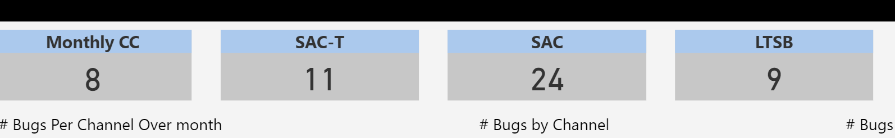

Filters (move in the header)

* By month
* GEM
* Area – do not need this as it is duplication of by GEM
* Channel – you can click on the donut chart to filter by channel

## Historical chart with #bugs per channel month over month – Start with May 2019



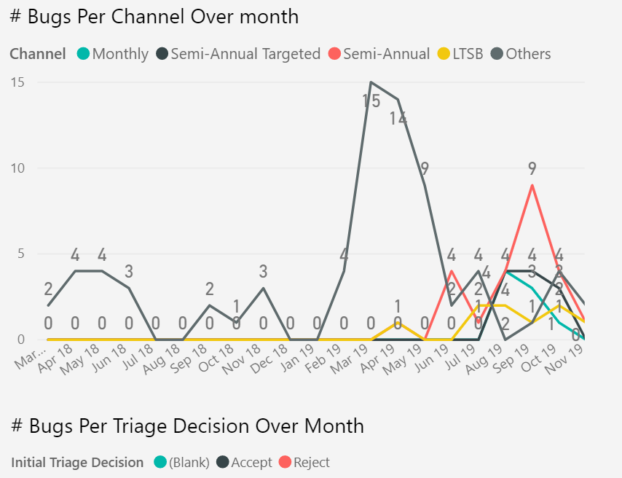

## triaged decision Accepted Fixed vs Reject total

**Accepted fixed** – triage decision Accepted and resolved reason fixed and blank (if resolved reason is empty then we need to see if the bug is active)

**Rejected –** Triage decision rejected

**Blank** = Untriaged

Make 5 charts per channel (incl NO channel)

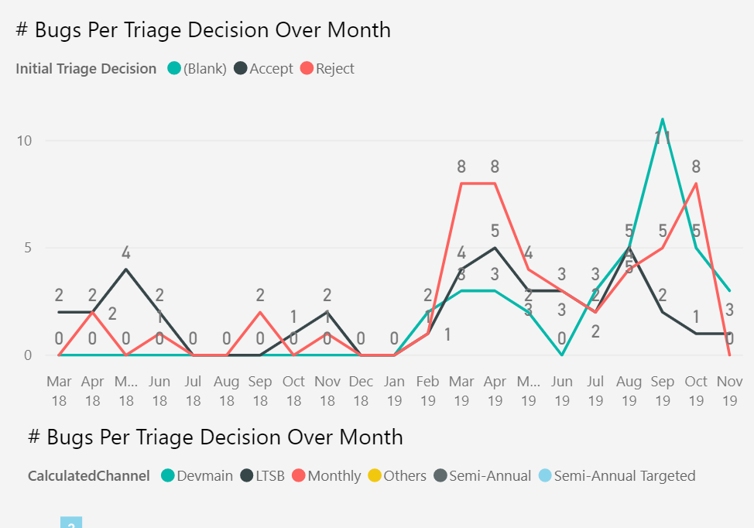

## chart for internally opened or customer reported w/ ticket id (Case #)

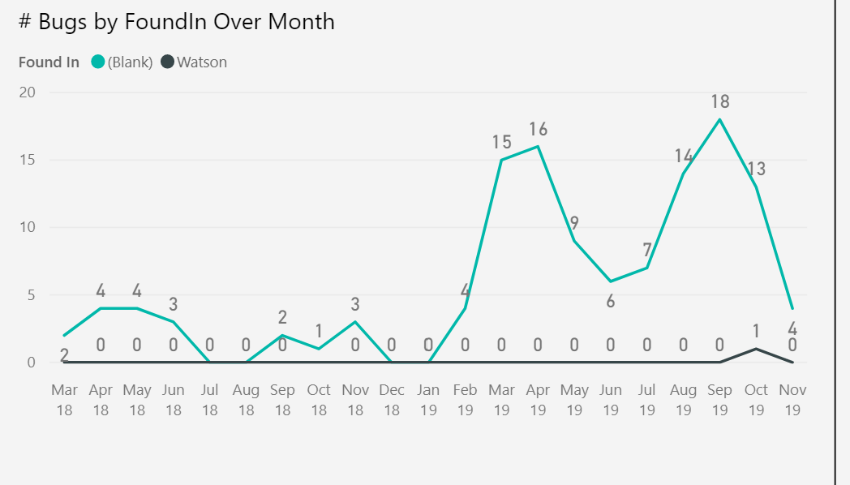

## Bar chart by tenant name top 10 – stack bar chart



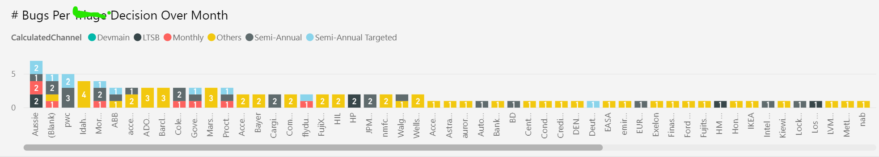

## total bugs per team – top 10

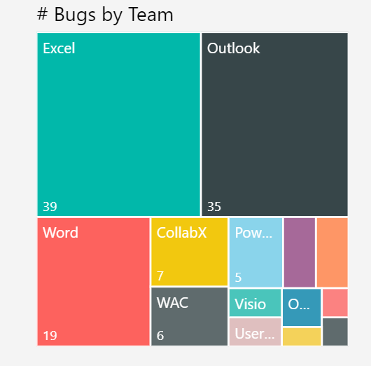

## GEM table with the data (All except state = closed)

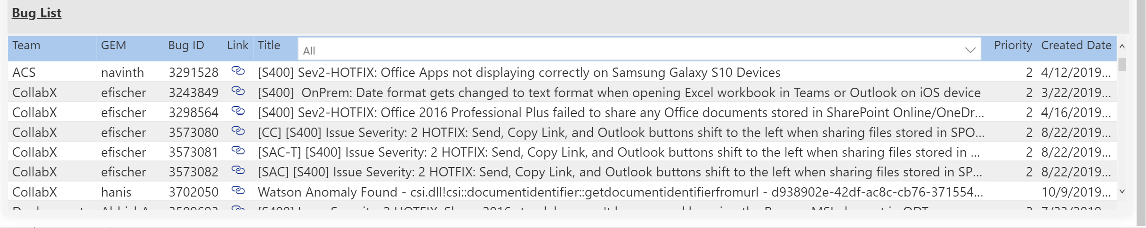

## Phase 2

## Chart with MTTR – LOOKS like it is Isabelle SLA which Stephen is BUILDING)



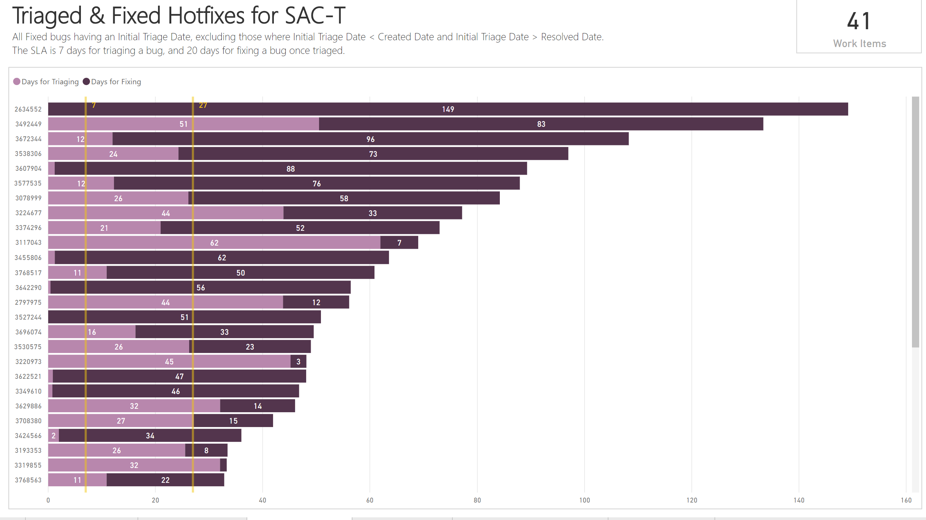

# Scenario2: Bring latest build released to S customer and # of customers on EOS builds

* **Scenario narratives:**

Tara, CSE VP is in shiproom. Before she didn’t have visibility into builds which are in-support and out of support for S customer and how it gets them to the latest builds to drives customer satisfaction. Now, having a shiproom view allows her to see the S customer impacting due to old version of office and enable her to drive necessary actions with appropriate teams.

* **Description of the proposed solution**

Dashboard which shows the build version for S500/S1500 tenants and the devices which are In- Support and Out of Support.

* **Prioritized Functional Requirements (High-Level)**

1. Build version, fork (aka version 2002 for Jan fork) and when was the build released (p0)
   1. We will add “Build” tab with S500/S1500 build version information   [https://mroui.trafficmanager.net/Dashboards/S500Analysis](https://nam06.safelinks.protection.outlook.com/?url=https%3A%2F%2Fmroui.trafficmanager.net%2FDashboards%2FS500Analysis&data=04%7C01%7Cagadkari%40microsoft.com%7Cff36722df5a342378a1c08d7e1899686%7C72f988bf86f141af91ab2d7cd011db47%7C1%7C0%7C637225853372785631%7CUnknown%7CTWFpbGZsb3d8eyJWIjoiMC4wLjAwMDAiLCJQIjoiV2luMzIiLCJBTiI6Ik1haWwiLCJXVCI6Mn0%3D%7C-1&sdata=HVPc8ByByfsYkpoXtSVerwJRJDcsNrCzW2Ye4J7kvzg%3D&reserved=0)
2. Total tenant w/ In-support and out of support data per channel (which might include subset of devices across different builds and channels)
3. Total devices in-support and out of support per channel (spread across all the tenants)
4. View with list of top 10 tenant w/ out of support devices per channel (
   1. *Open issue*: can we do this all version combined or keep the data separate for each build version).

|  |  |  |  |
| --- | --- | --- | --- |
| **#** | **Requirement** |  | **Priority** |
|  | Build tab |  | P1 |
|  | Per channel data (refer mock 2.1.1) |  | P1 |
|  | Top 10 tenant list for Out of support devices (refer mock 2.1.1 |  | P2 |
|  | Tenant filter (refer mock 2.1.2) |  | P2 |

* **Partners and Dependencies**

*High-level call-out of the partners and dependencies for the feature.*

|  |  |
| --- | --- |
| **Who** | **What** |
| DIG | Kusto Data |
| IDEA | Tenant data |
| MROStore | Build release information |

Questions we’re trying to answer are very much for s500/s1500 tenants on all the channels (including MEC) and understand the builds on the devices by build version. Attached are meeting notes with [@Bruno Josset](mailto:Bruno.Josset@microsoft.com) for more details.

1. Why do we need this report?
   1. in shiproom where you can show the #of S500 tenants which are EOS? And how releasing a new build would impact them? is anyone is on SAC-T builds or not? etc
   2. The report that DIG has created you have to do few click through to get to some answers & still it does tell you the full story. Plus, it is refreshing once or twice a month, so you can find data for older builds not the latest ones….
2. How to access data for build version information? We’ve 2 options -
   1. Curate build data considering that we’ve access to the tenant and build information d

                                                         i.      Tenant information – We can make a call to IDEAS data (like how Salim is using the tenant information)

                                                       ii.      Calculation for the EOS - done by RDX has it

                                                     iii.      Build information - RDX has it in MROStore

* 1. DIG Kusto data –

                                                         i.      we can keep the data consistent across the currency report for s500 and s1500

                                                       ii.      has tenant info, EOS calculation and build info (we see that information [here](https://nam06.safelinks.protection.outlook.com/?url=https%3A%2F%2Fmsit.powerbi.com%2Fgroups%2F9e7c1a6e-3bef-4989-8025-8cecb6255fa1%2Freports%2F58523ea2-4fd1-4e01-89cd-791d6a0f1f77%2FReportSection36c29025ab3f6a171297%3Fchromeless%3D1&data=04%7C01%7Cagadkari%40microsoft.com%7C7e9cad6742aa4476fcb908d7e237b8a2%7C72f988bf86f141af91ab2d7cd011db47%7C1%7C0%7C637226601293170718%7CUnknown%7CTWFpbGZsb3d8eyJWIjoiMC4wLjAwMDAiLCJQIjoiV2luMzIiLCJBTiI6Ik1haWwiLCJXVCI6Mn0%3D%7C-1&sdata=fCXa53k9uaRxPCW%2FCXF4LBNIYGO8lyTbhdb8VSzUF88%3D&reserved=0))

                                                     iii.      need to find out if the data update twice a month or the BI report is the updated twice a month. (Bruno or Parikshit to investigate)

Option B – would be better choice due to b(i) and b (ii)

## Build tab

We will add “Build” tab with S500/S1500 build version information   [https://mroui.trafficmanager.net/Dashboards/S500Analysis](https://nam06.safelinks.protection.outlook.com/?url=https%3A%2F%2Fmroui.trafficmanager.net%2FDashboards%2FS500Analysis&data=04%7C01%7Cagadkari%40microsoft.com%7Cff36722df5a342378a1c08d7e1899686%7C72f988bf86f141af91ab2d7cd011db47%7C1%7C0%7C637225853372785631%7CUnknown%7CTWFpbGZsb3d8eyJWIjoiMC4wLjAwMDAiLCJQIjoiV2luMzIiLCJBTiI6Ik1haWwiLCJXVCI6Mn0%3D%7C-1&sdata=HVPc8ByByfsYkpoXtSVerwJRJDcsNrCzW2Ye4J7kvzg%3D&reserved=0)

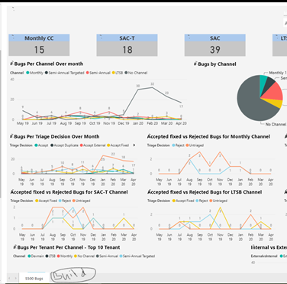

## How to access data for build version information? We’ve 2 options -

* 1. Curate build data considering that we’ve access to the tenant and build information d
     1. Tenant information – We can make a call to IDEAS data (similar to how Salim is using the tenant information)
     2. Calculation for the EOS - done by RDX has it
     3. Build information - RDX has it in MROStore
  2. DIG Kusto data –
     1. we can keep the data consistent across the currency report for s500 and s1500
     2. has tenant info, EOS calculation and build info (we see that information [here](https://nam06.safelinks.protection.outlook.com/?url=https%3A%2F%2Fmsit.powerbi.com%2Fgroups%2F9e7c1a6e-3bef-4989-8025-8cecb6255fa1%2Freports%2F58523ea2-4fd1-4e01-89cd-791d6a0f1f77%2FReportSection36c29025ab3f6a171297%3Fchromeless%3D1&data=04%7C01%7Cagadkari%40microsoft.com%7Cff36722df5a342378a1c08d7e1899686%7C72f988bf86f141af91ab2d7cd011db47%7C1%7C0%7C637225853372785631%7CUnknown%7CTWFpbGZsb3d8eyJWIjoiMC4wLjAwMDAiLCJQIjoiV2luMzIiLCJBTiI6Ik1haWwiLCJXVCI6Mn0%3D%7C-1&sdata=la1fWS9zu%2BV8rqcBPxjUgb4uhpiPb9C0GtToweHkSFs%3D&reserved=0))
     3. need to find out if the data update twice a month or the BI report is the updated twice a month. (Bruno or Parikshit to investigate)

Option B – would be better choice due to b(i) and b (ii)

### Visual w/o tenant id filter

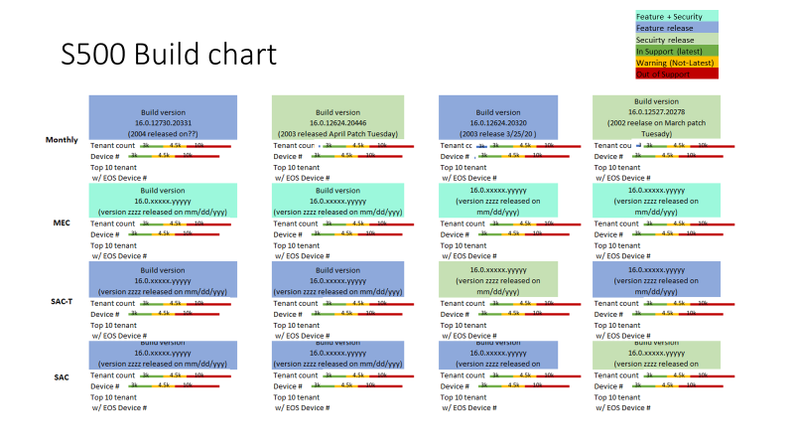

### Visual with tenant id filter

– not sure if we can do this due to tenant id exposure.

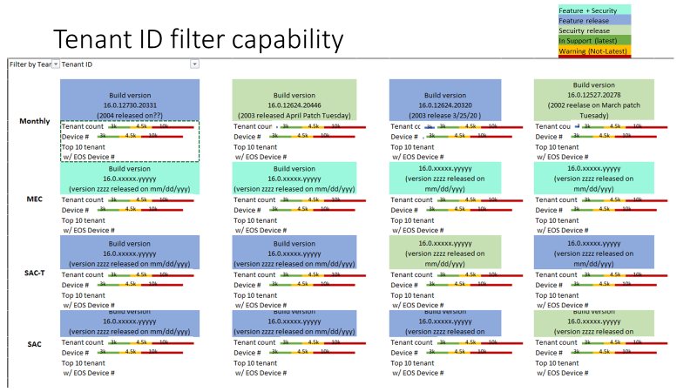

### Per tenant deep dive data we should link to <http://aka.ms/oxotenantcurr>

## Why do we need this report?

* 1. in shiproom where you can show the #of S500 tenants which are EOS? And how releasing a new build would impact them? is anyone is on SAC-T builds or not?...etc
  2. The report that DIG has created you have to do few click through to get to some answers & still it does tell you the full story. Plus, it is refreshed once or twice a month, so you can find data for older builds not the latest ones….

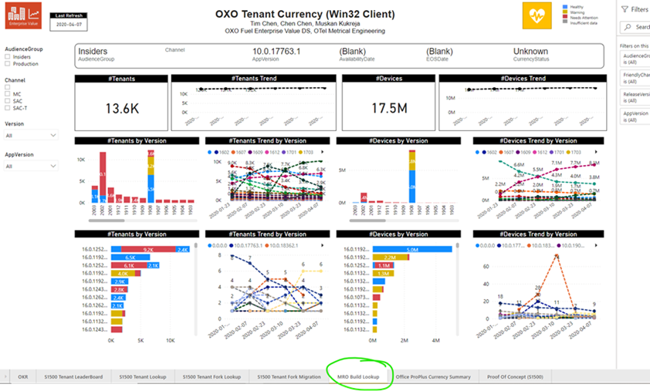

Once we ‘ve proto-type and able to see what we can do based on the data that is available, we will look into next set of question. Some of early thinking is listed below

Who is not using the target builds? Or anybody is < X % of tenants/devices on targeted?

When we release a build which tenants are impacted/ affected?

Any outliers – do we know which S customers are in Weird state?

What the ratio & channels – MT, MC, SACT and SAC? (have pie chart and upon clicking on the number it expands to the list of tenants)